Developing a Computer Game

Table of Contents

User Requirements 1

Game Designs 1

Game Development 3

Testing 7

# User Requirements

|  |  |
| --- | --- |
| * The computer games must appeal to children aged 8-12 * The game must include a playable character for the user to interact with * The game must use a range a game asset | * The game must be two dimensional and include different platforms for the user to jump between * The game must detect collisions made by the character |

# Game Designs

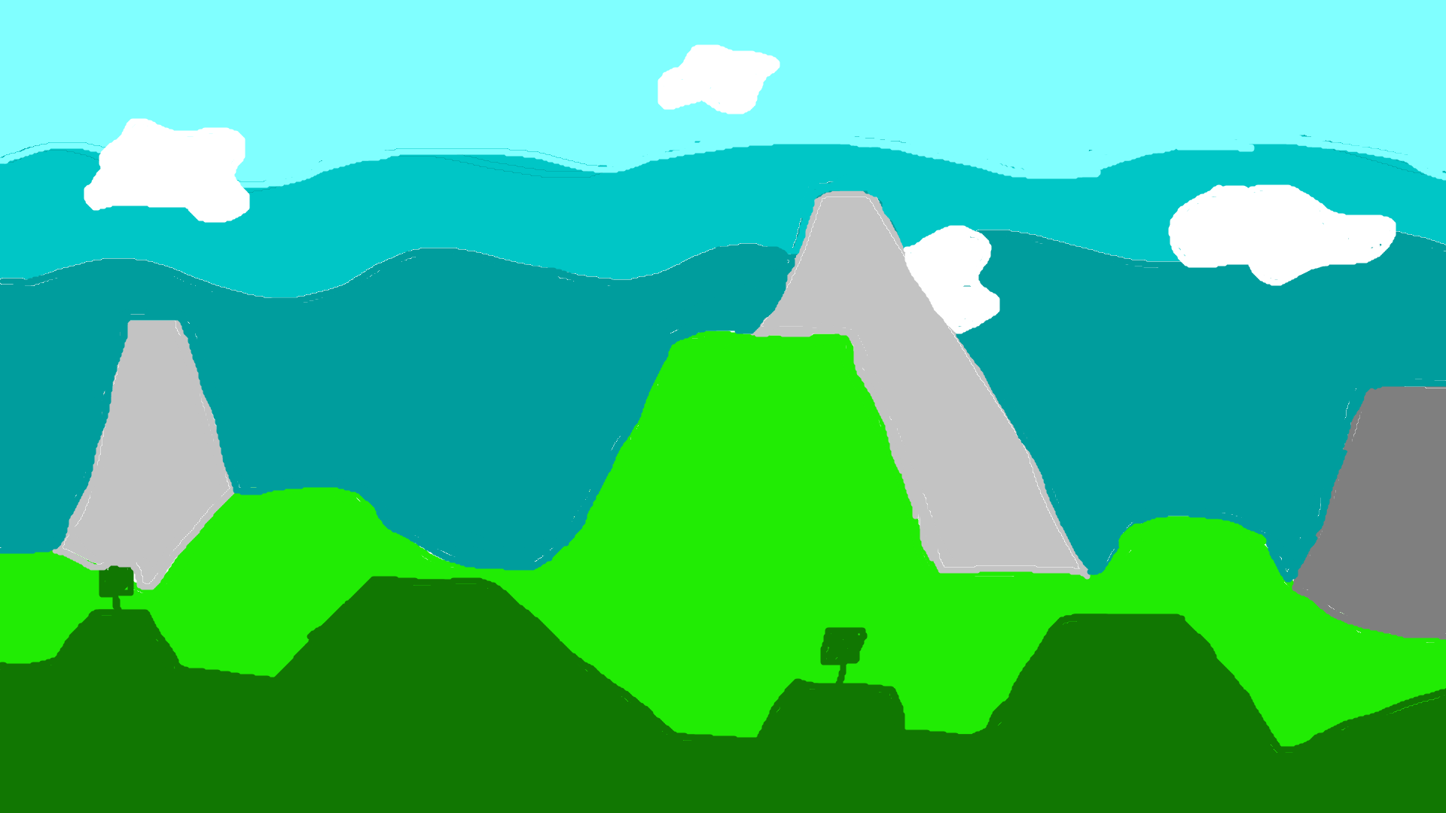During the design phase I chose to go with bright colours such as green, blue, yellow, and red these colours are more attractive towards the target audience, ages eight to twelve. For the character I chose to design a basic stickman character that would be memorable for the players. This meant that the game would be more appealing for the target age ranges and not prove to be complicated and boring.

Here is the final design for the background that will be present in the game. After I had finished designing this, I moved on to creating some character designs. This include some animation sequences for jumping, walking and an idle animation.



The four pictures above show the different states for the playable character the first picture is the idle state, when the character isn’t moving. The second picture shows the character about to start walking, the third picture shows the character mid-air jumping. Finally, the last picture shows the character in its crouching state. After designing some character sprites, I then moved onto the tiles the player would move around on. To match with the background theme, I chose to create some grass and dirt tiles, with some variants with the grass block.

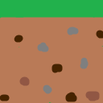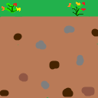

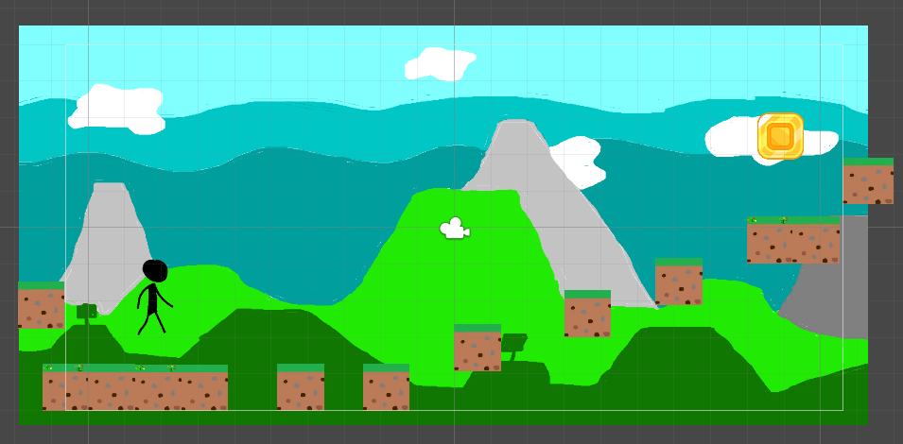

The picture above shows the final design and layout that will be used in the game this shows the tile/block placements and the end game achievement which will be the coin.

# Game Development

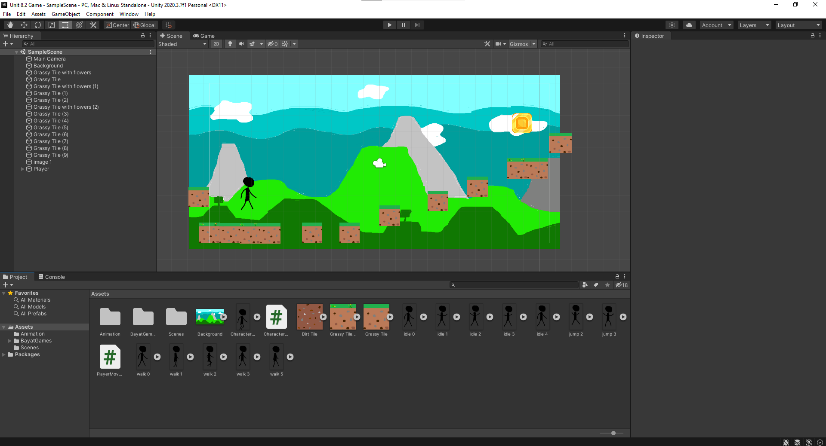To start of the development of the game I started by importing all the asset that will be used in the game as well as the character controllers and scripts that will be used.

I then proceeded to setup some sorting layers that would ensure that all the assets sit properly on the screen. This would help prevent objects from being behind the background or the character sitting Infront of the blocks.

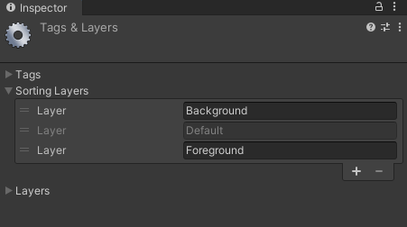

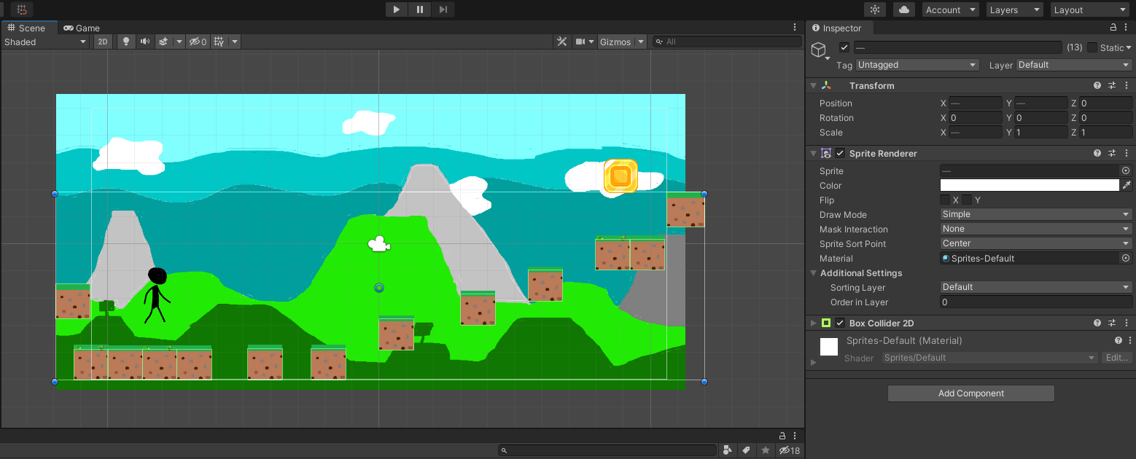The three layers helped solve this issue. The first layer was solely for the background, this made sure that the background and only the background would be at the back. Then the default layer would be used for the blocks and the coin. And the final layer was for the character.

Once that all the assets had been placed on the screen, I then proceeded to add components such as box colliders. This would enable the character and the coin to sit on top of the ‘ground’ and not fall directly through and off the screen/playable area. I also added box colliders to the character and the coin this would also mean that they do not fall directly through the ground boxes. I also added another component to both the character and the coin called rigid body. This is basically gravity and would allow them to fall and stay stuck in the middle of the air. I also added a circle collider for the characters legs. This would aid with smooth walking ensuring that the character would not get stuck on any ledges or sharp corners.

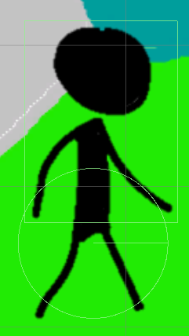

Once all the components had been added and setup correctly, I then moved onto make the character move to do this I used a premade character controller and a script.

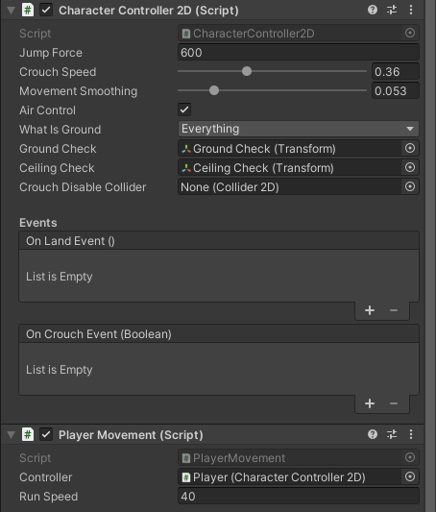

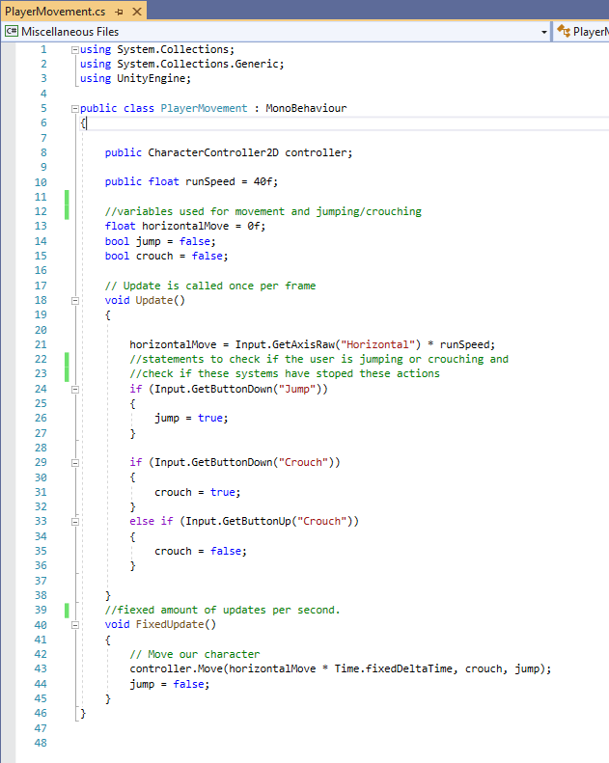

Here is the script used to control the player movement, it used variables that link back to the movement controller.

# 

# Testing

I encountered a few problems during the development phase, the first issue that I encountered was I couldn’t get the character to move left or right, it was only able to jump. It turned out that it was a problem with the code in the player movement script.

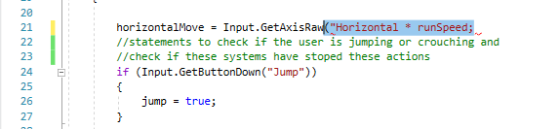 The error persisted on line 21 where I had forgot to close of the quotations and brackets. Once fixed the character was able to move properly as intended. The picture bellow shows the fixed solution.



The second issue that I came across was the implementation of animations and setting the criteria that start and finish each criterion. This became and issue when 509 critical issues appeared resulting in the development process of the game being restarted. I could not find a solution for this issue, so I decided not to include any animations. This is not what I had planned during the design phase.

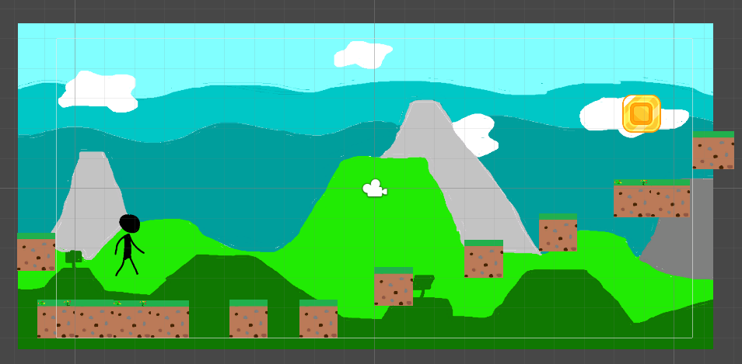Another issue I came across was the ability for the character to walk off the edge of the play area. This became an issue when testing because it meant that the game became broken and needed a restart to put the character back in the intended play area. To solve this issue, I added two blocks with collision detection on the edge of the play area this prevented the user from walking outside the play area.

After further testing I found that the character could still jump on top of these blocks and then walk outside of the play area so I add too more blocks just above the first two preventing the character from being able to jump out of the play area.

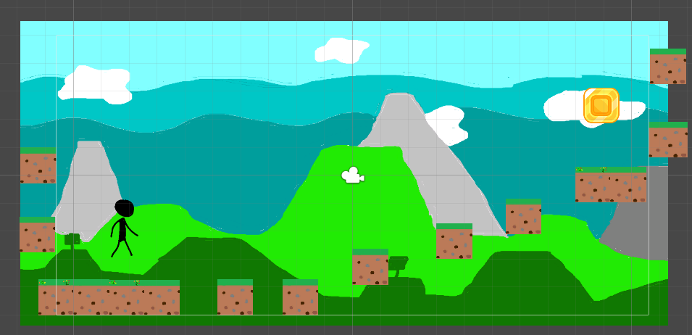

# Evaluation

Overall, the game met the criteria set by the client. The design choices I made appealed to the target age group of 8-12-year olds. For example, the bright colours used in the background, the simple yet memorable character. I also made the level suitable for younger children, by not making it too difficult it will make the player return to the game to continue playing, whereas on the other hand id the level was too hard for users to complete then they would have a negative association with the game and not want to return. My game also includes a playable character with collision detection added to the coin, character, and the platforms the character stands on.

One thing that could improve the game is the addition of animations. This would benefit the game a lot increasing the enjoyment and the amount of fun it gives it players. Although it wasn’t one of the direct criteria stated by the client it would have improved the game.